**Kanban for NetSuite**

**User Guide**

Table of Contents

Kanban for NetSuite 3

Kanban Preparations 4

Kanban User Access 4

Kanban Saved search 5

Kanban Configuration 8

Kanban Columns 14

Kanban Card Actions 20

Move to Production 25

# Kanban for NetSuite

The Kanban for NetSuite is a very powerful tool that enables a more efficient way of working for you and your team, regardless business function. Use the prebuilt Kanbans or configure your very own Kanban for your particular business processes, based on any standard or custom table in Netsuite.

The process of getting started with Kanban for NetSuite consists of a few simple steps.

Use one of the many prebuilt Kanbans simply by displaying it in a custom portlet on your dashboard.

OR

Configure your very own Kanban by creating a saved search to select accurate data for your Kanban, define the columns for your Kanban in the configuration record, define your Kanban functionalities and adjust the layout of the Kanban.

Finish the process by giving access to your Kanban for selected users.

# Kanban Preparations

Before starting with the configuration of the Kanban in your NetSuite account it is a good idea to design a draft of the layout on paper and decide what data and functionality to include.

You should mainly consider:

* Which record will be presented in the Kanban (the record which the search will be based on)
* Which columns will the Kanban consist of (typically based on a status field for the selected record)

In this User Guide the *Kanban – Prospect* board will be used as an example for the step-by-step configuration needed to set up a Kanban board. Once all configurations are done, the end result should look like the Kanban board in the picture below.

*In this example a Kanban column has been created for each NetSuite standard status a prospect may have (Prospect-In Discussion, -Identified Decision Makers, etc.) and one Kanban column has been created for NetSuite standard status Customer-Closed Won.*

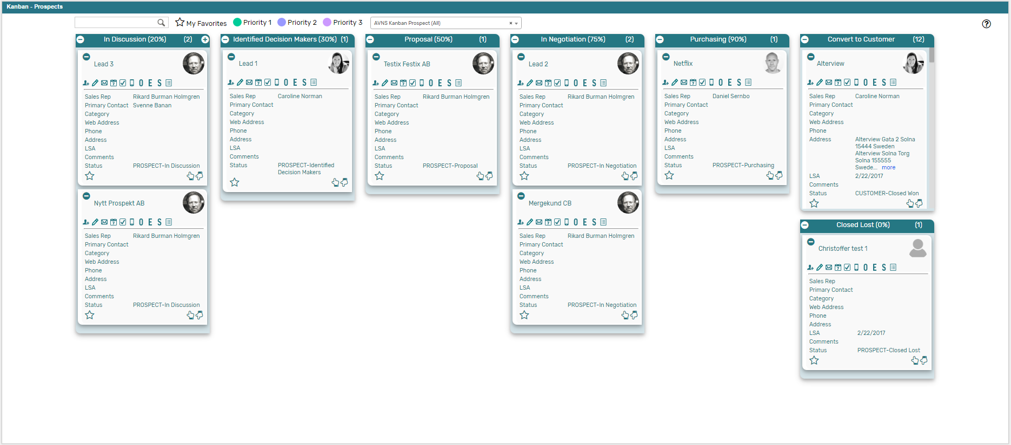

# Kanban User Access

The Kanban Process Administrator role included with the bundle has a Test Area where all prebuilt Kanban boards, as well as your customized Kanban boards can be previewed before moved to production. In order to preview Kanban boards in the test area a Kanban User access is needed. Navigate to Administration 🡪 Kanban Users to create a Kanban Users record for the user. Once this is done, the Kanban boards will be available to preview in the test area.

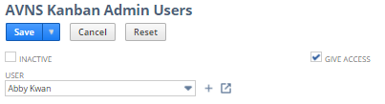

# Kanban Saved search

1. General information   
   *Navigate to Administration 🡪 Kanban Setup 🡪 Saved Searches 🡪 New   
   (using the role ”Kanban Process Administrator”)*  
     
   Select the record which the search will be based on – the record which will be presented in the Kanban. Give the search a name and make sure to make it a public search.  
     
   *In this example the search is based on the Customer record.*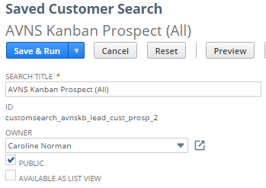
2. Criteria   
   Define any criteria to apply on the search in order to only include relevant posts.  
     
   *In this example criteria regarding the status field has been included, as the Kanban columns are based on the status field. Only prospects and prospects which has been converted to Customer-Closed Won within the last month will be displayed in the Kanban board.*

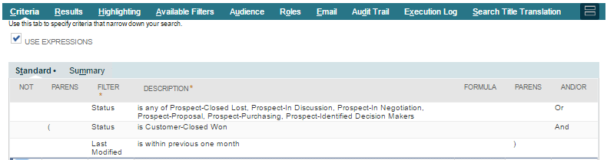

1. 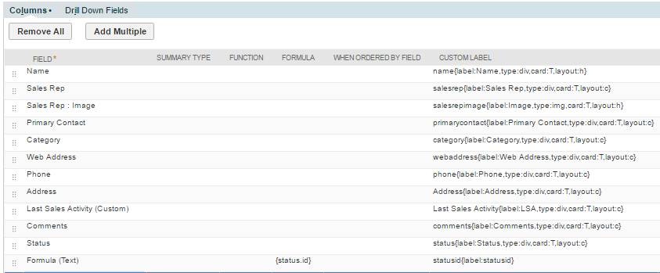Results   
   Select which data to include in the Kanban in the Results-tab. It is possible to include fields from the base record, from child records and formula fields.  
     
   *In this example the selected information regarding the prospect includes Name, Sales Rep, Web Address, Phone, Last Sales Activity, etc., all of which will be displayed on the Kanban cards.   
     
   Also selected is a Formula (text) field which will not be displayed in the Kanban, but which will be used in the Kanban configuration to define the Kanban columns (status.id).*
2. 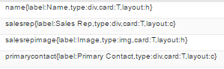Custom Labels   
   Define Custom Labels for the fields in the Results-tab in in order to display the data on the Kanban cards. To display the selected data/fields on the Kanban cards, the labels must have a certain syntax. Depending on the field and where to display the information, the syntax differ slightly.  
     
   *In this example labels for both Card header and Card content has been defined.*



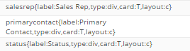



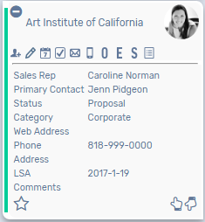

Header (*layout:h*)

Content (*layout:c*)

* 1. *name –* The initial text right before the {…} section is the identifier when referring to the field in the Kanban configuration at a later point. Essentially it is possible to write anything, but it is recommended to enter a descriptive name for the field, with no blank spaces.
  2. *label:Name –* This will be the label name displayed on the Kanban card. If the field will be displayed in the header section of the Kanban card, the label will not be visible on the Kanban card, only the data.
  3. *type:div –* This defines what type of data the field contains, *div* is the default type for any kind of text field (including date fields), for image fields the type is *img* (*type:img)* and URL-links the type is *href (type:href).*
  4. *card:T –* This defines if the field should be displayed on the Kanban card or not (T = true, F = false).
  5. *layout:h –* This defines where on the Kanban card the data should be displayed, *layout:h* indicates the data should be displayed in the header section of the card, *layout:c* indicated the data should be displayed in the content section of the card.  
       
     

The Saved Search also includes fields which does not have a custom label with a correct syntax required in order to be displayed in the Kanban, but which still are important for the Kanban Configuration.

*In this example the Kanban columns are based on the status field, which therefore needs to be included in the Saved search, with a custom label defined (label:status).*

1. Save  
   Finish by saving the search, and again, make sure to make it public.

# Kanban Configuration

1. 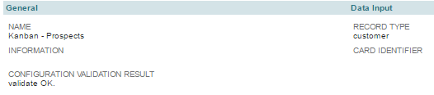General & Data Input   
   *Navigate to Administration 🡪 Kanban Setup 🡪 Kanban Configuration 🡪 New*  
     
   Select a name for the Kanban configuration post, which will be displayed in the dashboard portlet at a later point. Enter additional information regarding the Kanban if desired. In the field *Record Type,* enter the internal id for the record your Kanban (and Saved search) is based on.  
     
   Once the Kanban Configuration post has been saved a validation of the setup will trigger, to ensure the configuration is complete without any information missing.  
     
   *In this example the name of the Kanban configuration record is ‘Kanban – Prospects’, no additional information has been entered and the setup has been validated.   
   The Kanban board (and Saved search) is based on the Customer record (which means the data input equals ‘customer’ – the internal id for the Customer record).*
2. 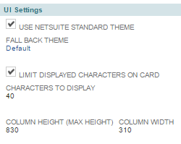UI Settings   
   Select User Interface settings for the Kanban, which includes selecting color theme, column size and the possibility to limit the displayed characters on the Kanban card.  
   1. *Selecting color theme*  
      By marking the checkbox *Use NetSuite standard theme* the colors of the Kanban will adjust to the selected color theme in the NetSuite account (General Preferences 🡪 Appearance). All basic themes are supported.

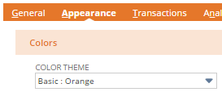

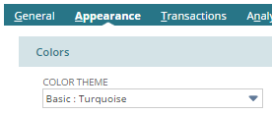

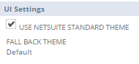

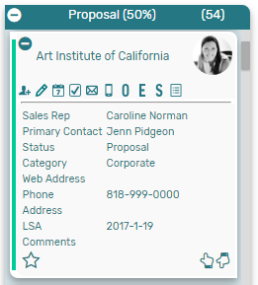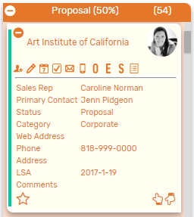

Also select one of the provided color themes in the field *Fall back theme,* which will be used for the Kanban if selected theme for the NetSuite account is not one of the Basic themes.

* 1. *Limit displayed characters*  
     Mark the checkbox *Limit Displayed Characters on Card* to avoid too much information on the Kanban cards. For example, if a comment field is selected to display on the Kanban card, it might be a good idea to limit the displayed characters to avoid that the card takes up too much space in the portlet.  
       
     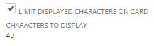
  2. *Set column height and width*  
     If desired, the Kanban columns can be defined to have a specific height and width. Enter preferred values in the fields *Column Height (Max height)* and *Column Width.*

1. Optional Functions  
   In the Kanban configuration it is also possible to enable *Use Favorites* and *Use Coloring* functionality, which is an efficient way of filtering the Kanban cards in the portlet.   
   1. *Use Favorites*When enabling the favorite functionality, by marking the checkbox *Use favorites*, a star-icon will appear on each Kanban card. By clicking on the star-icon, the card is marked as a favorite. The Kanban board can then easily by filtered to only display favorited Kanban cards by clicking on the Star-icon in the filter area of the Kanban portlet.



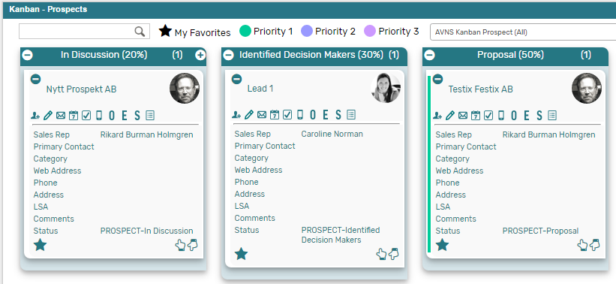

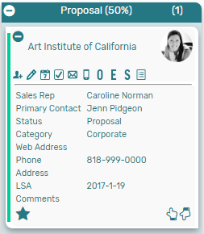

* 1. *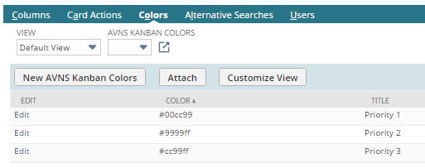Use Coloring*When enabling the color functionality, by marking the checkbox *Use coloring*, the Kanban cards can be marked with a color by clicking along the left side of the card. The Kanban board can then easily be filtered to only display Kanban cards marked in a certain color by clicking on that color icon in the filter area of the Kanban portlet.  
       
     Define the colors to use for the Kanban board in the Kanban configuration, as well as what the color represents in the Kanban.

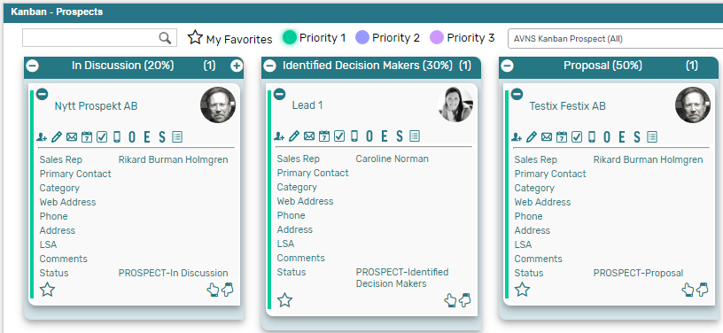

1. 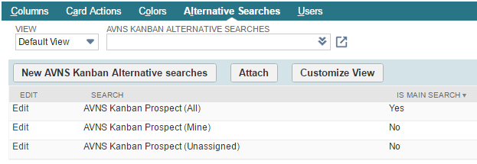Alternative Searches  
   In the subtab Alternative Searches the Kanban configuration post is linked to the saved search created in a previous step. It is possible to link several saved searches to the configuration post, enabling the Kanban board to display cards depending on which search is selected. At least one search is required in order to display the Kanban board, which should be marked as Main search. This search will be the default search displayed in the Kanban board.  
     
   In this example there are three searches selected as alternative searches for the ‘Kanban – Prospects’ board, with the search ‘AVNS Kanban Prospect (All)’ marked as main search.

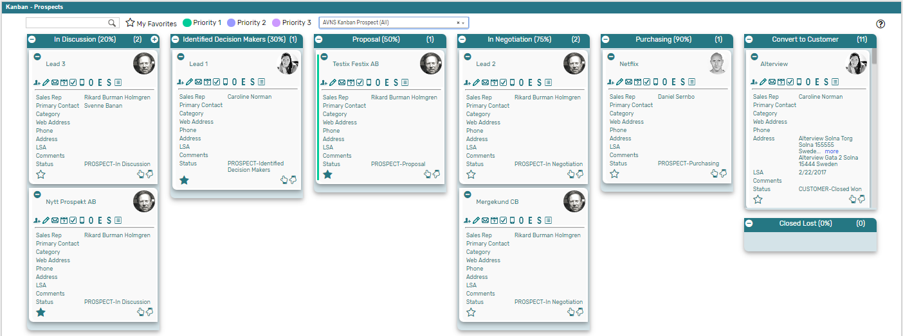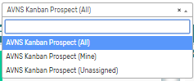

1. Card SettingsIn the section Card Settings further settings can be made.  
   1. *On Double Click*It is possible to add functionality when double clicking on a Kanban card, by defining a Kanban Card Action. The field is optional and can be set up at a later point.  
        
      ***Please refer to section ‘Kanban Card Action’ in this User Guide for a detailed description on the different types of Card Actions available and how to define them.***
   2. *Help*In the help field it is possible to enter a URL linking to a selected webpage (for example a HTML-help section for the particular Kanban board). The field is optional and can be set up at a later point.
   3. *Max Search Result*Enter a number for the maximum number of Kanban cards to display in the Kanban board (even if the saved search contains a higher volume of data).   
        
      Saved searches containing a high volume of data can affect the performance of a Kanban board. To avoid reduced performance, it is recommended to enter a number in the *Max Search Result* field.   
        
      *Maximum number of Kanban cards which will be displayed in the Kanban board is 300 (even if the Saved search returns more than 300 results).*

# Kanban Columns

The configuration of the Kanban columns will decide the layout of the Kanban board. Each column will typically represent a status for the record presented in the Kanban.

*Please note that at least one saved search need to be connected to the Kanban Configuration post (subtab Alternative Searches) in order to complete the Kanban Column setup.*

In this example the Kanban columns represent a status a prospect may have (*Prospect-In discussion, -Identified Decision Maker, etc.*).  
  
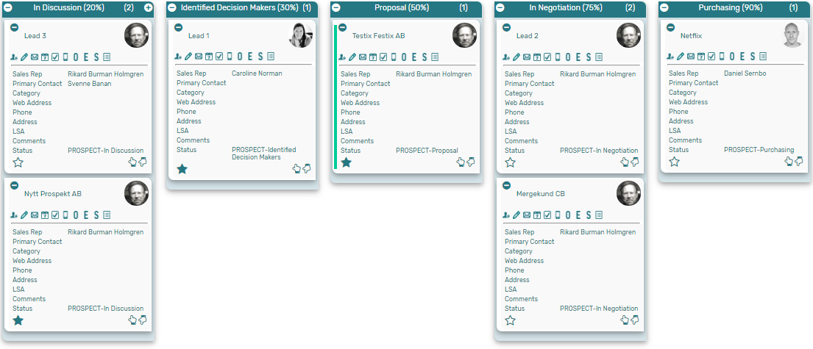

1. ColumnCreate a new Kanban Column from the Columns subtab in the Kanban configuration record.   
   1. *Name*Select a name for the Kanban column, which will be the displayed title for the column in the dashboard portlet at a later point.
   2. *Parent*  
      The *Parent* field contains information about the associated Kanban configuration post (auto populated when the column is created from the Kanban configuration).

*Information*  
Enter additional information regarding the Kanban column if desired.

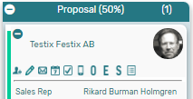

1. Column Display Order
   1. *Order*Select the position of the Kanban column by entering a number in the *Order* field, if it is the first column in your Kanban board, enter ‘1’ in the *Order* field.
   2. *Sub Order*If the column contains multiple columns, use the *Sub Order* field to decide the position within the column.

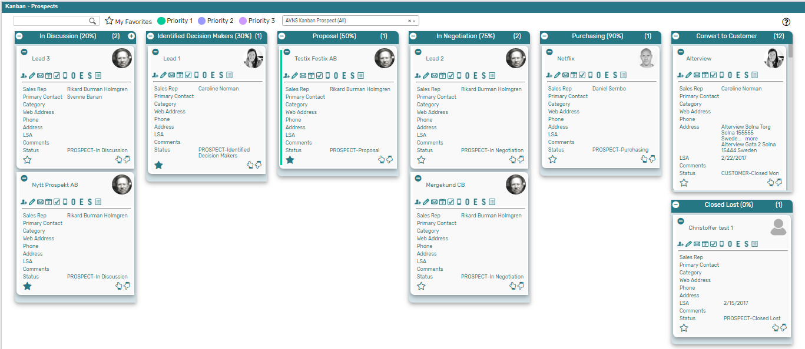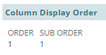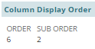

1. Column ConditionThe Column Condition section is one of the most important configurations when setting up a new Kanban board, as this is where the Kanban columns are paired with the Saved search and hence decides which record to display in which column.   
     
   The Saved search included the field (with a custom label) which the Kanban columns are based on, in order to access the field in the Column Condition section.  
   1. *Field –* select the field from the saved search to base the column on
   2. *Operator –* select the appropriate operator
   3. *Value –* enter the value for the status corresponding to the name of the column

*In this example each Kanban column represent a status for the prospect record. Therefore, the ‘statusid’ field from our Saved search is selected in the Column condition field called ‘Field’ and in the ‘Operator’ field ‘is’ has been selected.  
  
The Kanban column named ‘In Discussion (20%)’ should only display records with the same status. Therefore, the internal id for the status corresponding to the status ‘In Discussion’ is selected in the ‘Value’ field, which is equal to 8.*

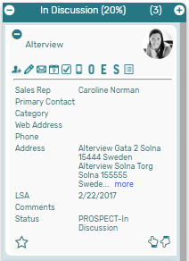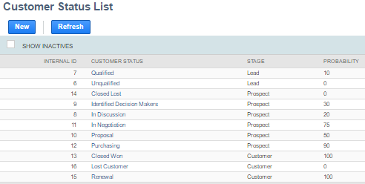

1. Card Actions  
   In the section *Card Actions* there are two configurations to be made - *Restrict Card Move to* and *Add a Card.*
   1. *Restrict Card Move to*This field defines how a Kanban Card can be moved between the columns in the Kanban board.   
        
      The multi-select field lists only the Kanban columns created for the Kanban configuration record they are intended for. It is therefore recommended to create all Kanban columns for the Kanban board first, before updating each Kanban column by selecting the column to which a card can be moved.   
        
      Please note that the current Kanban column also needs to be selected to enable card move within the column.  
        
      *In this example all columns for ‘Kanban – Prospect’ (the Kanban configuration record) have been selected, which means a Kanban card in the ‘In Discussion (20%)’ column can be moved to all other columns in the Kanban board. Since the ‘In Discussion (20%)’ is selected in the ‘Restrict Card Move to’ field, Kanban cards can also be moved up and down within the column.*

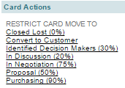

* 1. *Add a Card -*   
     For each Kanban column it is possible to add a Card by clicking on the + icon in the top right corner of the Kanban column, which means adding a new base record. Depending on which column the card is added from, the status should differ to match the status of that particular column.  
       
     *In this example then status will be ‘PROSPECT – In Discussion’ when adding a new card.*  
       
      ***Please refer to section ‘Kanban Card Action’ in this User Guide for a detailed description on the different types of Card Actions available and how to define them.***

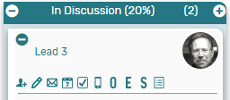

1. 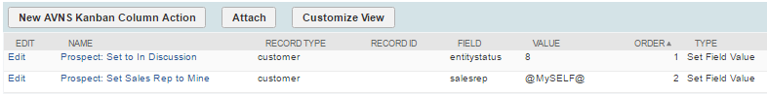Column Actions  
   The subtab *Column Actions* defines what actions to trigger when a Kanban card is created or moved to the column. It is possible to have several actions trigger for each column if desired. The most important Column Action to define is to update the status of the Kanban card (base record) to match the status of the column.  
   1. *Name –* give the Column Action a name, preferable a name describing the action.
   2. *Parent –* the Kanban Column is pre-selected as parent record.
   3. *Record Type –* enter the internal id for the base record of your Kanban (and Saved Search)
   4. *Field –* in the drop down list, select the field from your (main) saved search which should be updated by the action.
   5. *Value –* enter the value which should be assigned to the Kanban card (base record).
   6. *Order –* enter a number to decide the order in which the Column Actions should be performed.
   7. 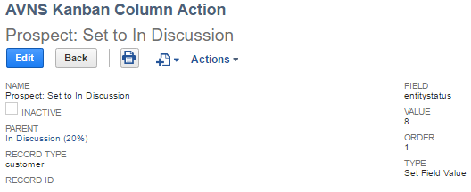*Type –* define what kind of action should be triggered.  
        
        
      *In this example the Column Action will set the status (entitystatus) of the record (customer) to ‘In Discussion’ (value 8). This means that whenever a card is created or moved to the column ‘In Discussion (20%)’ the status for that record will be updated to ‘In Discussion’.*
2. Column Aggregation  
   The Column Aggregation subtab provides the possibility to present summarized information in the column header. By default, each Kanban column will present a number within brackets in the column header. This number is equal to the number of Kanban cards in the column.   
     
   The configuration for presenting additional summarized information in the header is done in the Column Aggregation subtab.

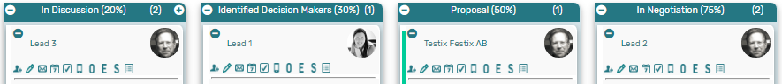

* 1. *Parent –* The Kanban Column is pre-selected as parent record.
  2. *Field –* Select the field from the Saved search to present in the Column header
  3. *Type –* define how the data should be presented in the Column header
  4. *Order –* enter a number to decide the order in which the column aggregations should be displayed in the Column header.   
       
     *In this example (from ‘Kanban – Customer by LSA’) a Column Aggregation has been configured for the ‘1-3 Months’ column to present the sum of unbilled orders for all Kanban cards (records) in the column.*

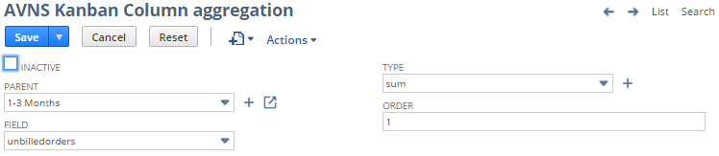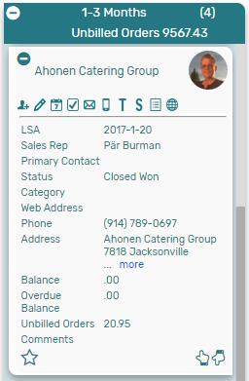

1. Minimize  
   In the top left corner of each Kanban column, in the header section, there is a – icon, providing a possibility to minimize all cards in the Kanban column for a more compromised view, only displaying company name, sales rep image and card actions.

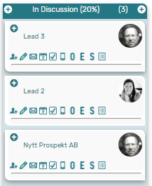

# Kanban Card Actions

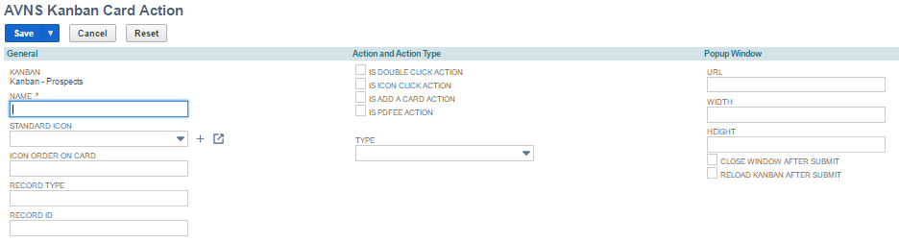  
The Kanban Card Actions provides a practical way of updating or adding information to a record without leaving the convenient overview of the Kanban board. There are four different types of Card Actions, used in different occasions.

1. General
   1. *Kanban*The field contains information about the associated Kanban configuration post (auto populated when the column is created from the Kanban configuration).
   2. *Name*Enter a descriptive name for the card action.
   3. *Standard Icon*Select one of the provided icons to display for the card action.

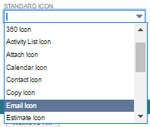

* 1. *Icon Order on Card*Select the position of the card action in the Kanban card.
  2. *Record Type*Enter the internal id for the record on which the board (and saved search) is based.
  3. *Record ID*The field is only required for PDFEE-actions. Enter the custom label from the saved search, for the field on which the PDF-report is based/filtered on.   
     For example, the Customer 360 report is based/filtered on the internal id for the customer record and the custom label for this field in the saved search is “customerinternalid” 🡪 enter “customerinternalid” in the *RecordID* field.

1. Action
   1. *Is Double Click Action*Mark the checkbox to indicate a double click action. This type of action is only used once per Kanban board and defines what action to trigger when double clicking on a Kanban card.
   2. *Is Icon Click Action*Mark the checkbox to indicate an icon click action. This type of action is used for every icon added to the Kanban card. Each icon will trigger a specific action.
   3. *Is Add a Card Action*Mark the checkbox to indicate add a card action. This type of action can be used once per Kanban column and will trigger an action to add a new record to the Kanban board.
   4. *Is PDFEE Action*Mark the checkbox to indicate a PDFEE action. This type of action will trigger a PDF-report to display.
   5. *PDF-Express ID*   
      The field will display only for *Is PDFEE Action.* Select PDF-printout from the list.
   6. *Type*Define the type of action to trigger, for example to open a popup window.

*When type is defined as ‘Popup Window’ the following information is required:*

1. Popup Window
   1. *URL*Enter the URL for the action to trigger, make sure the link is generic.   
      For example, if the action should open a popup window to enter a new note on the prospect record:   
      1. 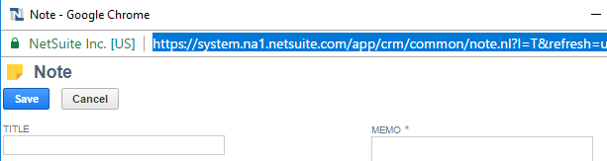Navigate to ‘Add new note’ from the prospect record and copy the URL.
      2. Paste the URL in the Card Action field, but remove everything before */app*



* + 1. Change the internal id in the URL to the generic value [recordid]
  1. *Width*Enter the width of the popup window in percentage.
  2. *Height*Enter the height of the popup window in percentage.
  3. *Close Window After Submit*Mark the checkbox to close the popup window after submit.
  4. *Reload Kanban After Submit*Mark the checkbox to reload entire Kanban board after submit.

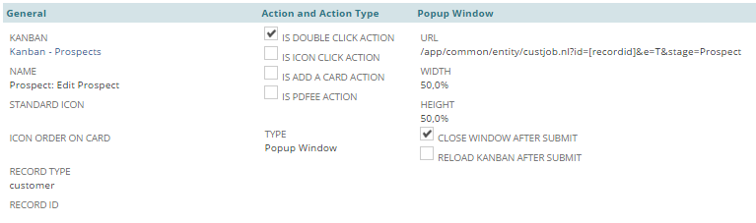*In this example a* ***Double click action*** *has been defined to edit the prospect record when double clicking on a Kanban card. The window will close after submit.*

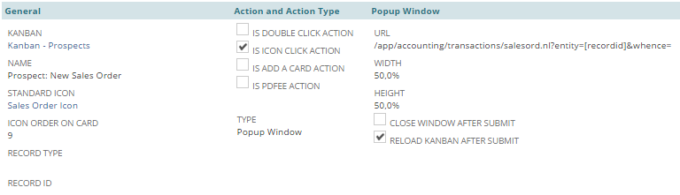*In this example an* ***Icon click action*** *has been defined to create a new Sales order to the record (prospect) when clicking on the Sales order icon in a Kanban card. The window will stay open after submit for a chance to inspect the Sales order, and the Kanban will reload after submit.*

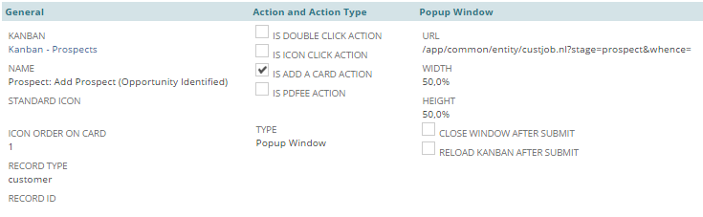*In this example an* ***Add a card action*** *has been defined to create a new prospect record (a new Kanban card) when clicking on the + icon in the column header section. The window will stay open after submit for a chance to inspect the new prospect record.*

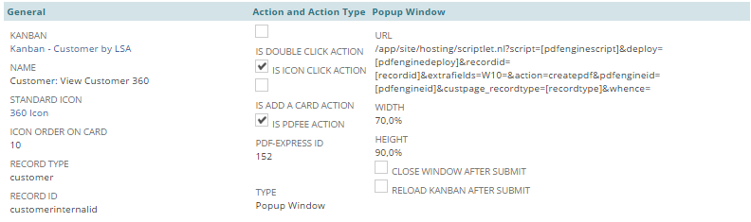*In this example a* ***PDFEE action*** *has been defined to generate a PDF-report when clicking on the 360 icon in a Kanban card (which is why the* ***Icon click action*** *checkbox also is marked). The window will stay open after submit for a chance to inspect the PDF-report.*

1. Minimize card & Move to top/bottom  
   There are two additional actions for Kanban cards, which does not need any configuration – minimize card and move card to top/bottom.  
   1. *Minimize*By clicking on the – icon in top left corner of each Kanban card, an individual card can be minimized to only display record name, Sales rep image and available card actions.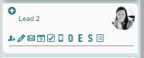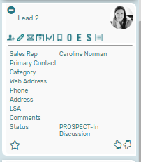
   2. *Move to top/bottom*  
      At the bottom right corner of each Kanban card there are two icons which will move the card either to the top of the Kanban column or to the bottom by clicking on one or the other.



Move to bottom

Move to top

# Move to Production

Moving a Kanban board to production consists of four simple steps – Add permission rights to the role you will use, create a Kanban User record for your selected users, add a custom portlet to your dashboard and select which Kanban board to display in the portlet.

*Please note a full access user is required to use Kanban for NetSuite.*

1. Add permission rights to the role

Using the NetSuite Administrator role, navigate to Setup 🡪 User/Roles 🡪 Manage Roles

Click Edit on the role you want use for Kanban and navigate to the Permission subtab to add the following permission rights:

* 1. List subtab  
     On the Permission 🡪 Lists subtab, add Custom Record Entries with View level permission.
  2. Setup subtab

On the Permission 🡪 Setup subtab, add SuiteScript with View level permission.

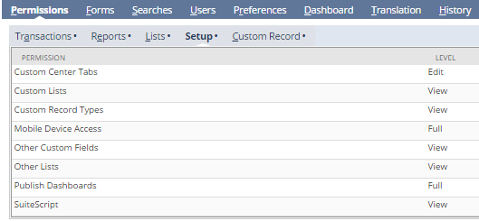

* 1. Custom Record subtab  
     On the Permission 🡪 Custom Record subtab, add permission to the AVNS Kanban custom records as follows:

|  |  |
| --- | --- |
| AVNS Kanban Admin Users | View |
| AVNS Kanban Alternative Searches | View |
| AVNS Kanban Card Action | View |
| AVNS Kanban Color | Full |
| AVNS Kanban Colors | View |
| AVNS Kanban Column | View |
| AVNS Kanban Column Action | View |
| AVNS Kanban Column aggregation | View |
| AVNS Kanban Configuration | View |

|  |  |
| --- | --- |
| AVNS Kanban Favorites | Full |
| AVNS Kanban Icon File | View |
| AVNS Kanban Icons | View |
| AVNS Kanban Position | Full |
| AVNS Kanban Standard ColorTheme | View |
| AVNS Kanban Theme | View |
| AVNS Kanban Timezone | View |
| AVNS Kanban User | Full |
| AVNS Kanban localization | Full |

1. Create a Kanban User record   
   Navigate to Administration 🡪 Kanban Users to create a Kanban User record for the selected user. A Kanban User record is required for all users who will use Kanban for NetSuite.   
   
2. Dashboard Custom Portlet  
   Add a Custom Portlet to your selected dashboard.

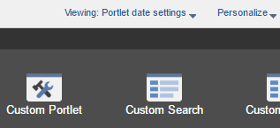

1. 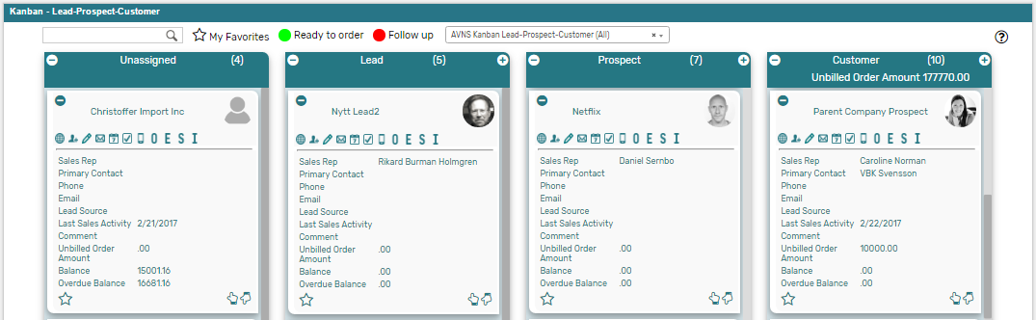Setup & Edit to select Kanban  
   Set up the custom portlet and select *AVNS Kanban* in the *Source* field and save.  
   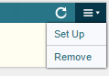 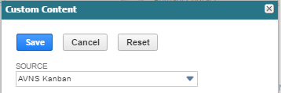  
     
   Go back to the menu in the top right corner to edit the portlet and select which Kanban to display in the *AVNS Kanban View* field and save.  
   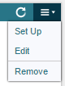 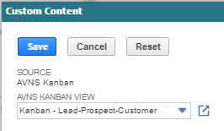  
     
   The selected Kanban board will display in the custom portlet.